**12th Annual**

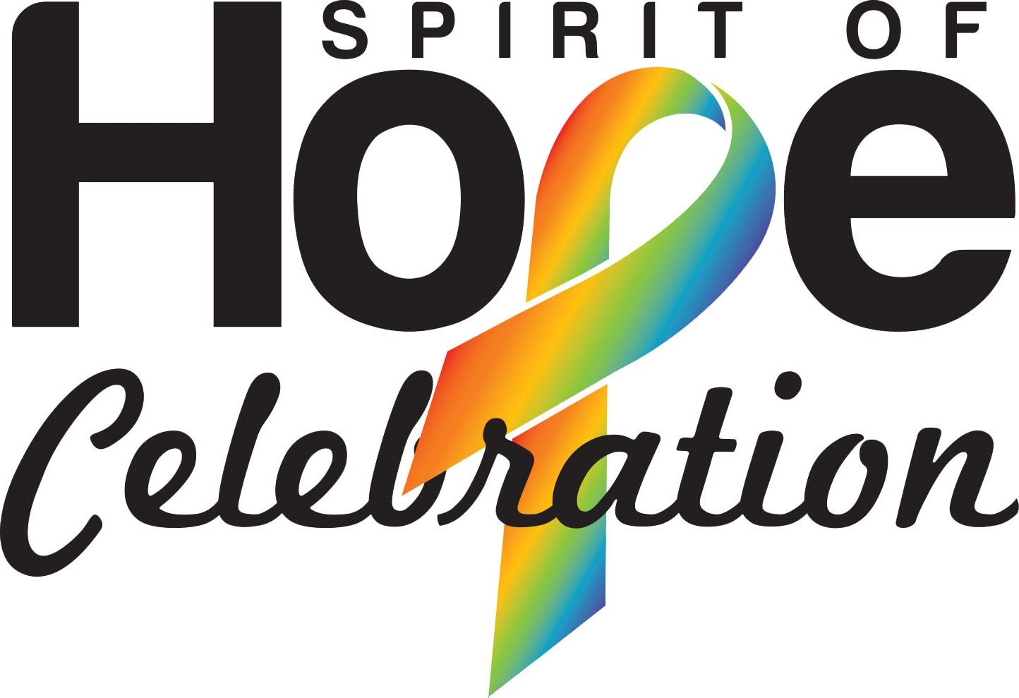  
  
**Friday, November 15, 2024**

**Mohegan Pennsylvania**

**Presented by:**

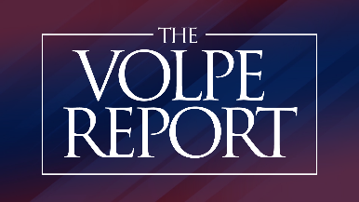

[**www.spiritofhopecelebration.org**](http://www.spiritofhopecelebration.org)

**Tribute to Courage Honoree: Peter J. Danchak  
Tickets: $140 per person**

**2024 Spirit of Hope Tribute to Courage Honoree  
Peter J. Danchak**

Peter J. Danchak is the Regional President of the Northeast PA region of PNC Bank.

Danchak joined PNC Bank in 1984 and has held various positions of responsibility in Corporate Banking. He was named Regional President of the Northeast PA Market of PNC Bank in January 2001.

Active in the community, Danchak currently serves as Chairman of AllOne Charities Foundation and Co-Chair of the Scranton Plan. He serves on the Board of Directors of AllOne Foundation, the Highmark Regional Advisory Board and the Greater Wyoming Valley Chamber of Commerce. In October of 2020, he was appointed to the Early Learning Investment Commission Emeritus Advisory Council.

He also previously served as a member of the Board of Directors of the ARC of Northeastern Pennsylvania Foundation, Blue Cross of Northeastern Pennsylvania, the Luzerne Foundation, the Northeast Regional Cancer Institute, the F.M. Kirby Center for the Performing Arts, King’s College, Keystone College, Johnson College, Junior Achievement of Northeastern Pennsylvania, the Pennsylvania Bankers Association, the Greater Pittston Chamber of Commerce, the Greater Scranton Chamber Board of Commerce and Scranton Lackawanna Industrial Building Company and the Greater Wilkes-Barre Chamber. He served on the Board of Trustees of Marywood University, Scranton Preparatory School and the University of Scranton Kania School of Management. Danchak also was the co-chair of the Pennsylvania Early Learning Investment Commission for 10 years.

Danchak received a Bachelor of Science degree in accounting from the University of Scranton and was awarded an Honorary Doctorate degree from them in 2018.

**Marta Gomes**

**James T. Gorman**

ESSA Bank & Trust

**Jo Ann Romano Hallesky**

Jo Ann Romano Hair Salon

**John & Jennifer Heil**

**Kristie Hynoski**Mohegan Pennsylvania

**Charles C. Jefferson**

Jefferson-Werner, LLC

**Angela Rempe Jones**Lackawanna Co. Treasurer

**Robin Long**

**John Mack**

**Linda Marino-Brooks**

**Joe Mattioli**The Baher Group

**Mark Mesko**  
Mesko Glass  
  
**Brian McQuestion**

Pride Mobility Products

**Philip Medico**

Medico Industries, Inc.

**Dan Meuser**  
U.S. Representative

**Dana Morris**

Regional Hospital of Scranton

**David J. Nape**

Centris Consulting, Inc.

**Christopher A. Peters, M.D.**NRCI Board  
  
**Vito Pizzo**

Pizzo Painting

**Casey Quinn**  
AHEAD

*Chairman*

**Leo P. Vergnetti**

Vergnetti Consulting

**Tom** **Blaskiewicz**  
McCarthy Tire

**Clarence Baltrusaitis**NET Credit Union

**Brigitte Baum**

eXP Realty  
 **Matt Beynon**  
BrabenderCox, LLC

**Jim & Susan Brady  
  
Dino Campitelli**

Serenity Lodge

**Trish & Nicholas Colangelo, Ph.D.**

**Richard P. Conaboy, Jr.**Endless Mountains Extended Care

**Ed Cosgrove**Scranton Counseling Center **William Davis**Office of Rep. Kyle Mullins

**Tom DePietro**

DePietro’s Pharmacy

**Maria Donahue**  
Higher Info Group

**Sonya Eddings**  
AARP Foundation

**Julie Eisenman**  
WNEP-TV

**Mary Erwine**

Erwine Home Health & Hospice

**Joseph G. Ferguson, Esq.**

DeAngelo Contracting Services  
  
**Traci Fosnot**

Highmark, Inc.

**Greg & Meghan Gagorik  
  
Nevin Gerber**Gerber Associates

**Billy Rinaldi**

Mark Construction Services, Inc.

**John P. Rodgers, Esq.**Caverly, Shea, Phillips & Rodgers, LLC

**Tammy Saunders**

**Frank Sepko**  
ConversionWorx

**Vince Scarpetta**

Pure Green Consultants, LLC

**P. Richard Scheller**

Geo-Science Engineering & Testing, LLC

**Patrick Sicilio**

Kem-Tek Industrial Chemical Supplies

**Steven J. Szydlowski, Ph.D.**

University of Scranton

**Joe Van Wie**  
Fellowship House

**Vanessa Vergnetti**   
Premier

**Chuck Volpe**Excalibur Insurance

The Volpe Report

**THE BOARD OF AMBASSADORS**

**What is the Spirit of Hope Celebration?**

The Spirit of Hope Celebration is an event hosted by the Board of Ambassadors. This cocktail party celebration includes an open bar, food stations, live music by The Exact Change, and a silent auction, lottery ladder and gift card guarantee. It raises money for the Northeast Regional Cancer Institute’s Community Based Cancer Screening Navigation Program, which helps individuals in northeast Pennsylvania to facilitate breast, cervical, colon and lung cancer screenings.

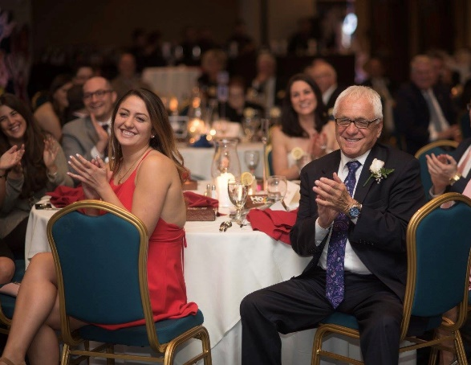

The Board of Ambassadors consists of individuals and business leaders in northeast Pennsylvania who come together to raise funds & awareness to fight cancer in the local community through their support and promotion of a gala event. We hope you will join with us in support of The Northeast Regional Cancer Institute and its mission of easing the burden of cancer in Northeast Pennsylvania.

**Who are the Board of Ambassadors?**

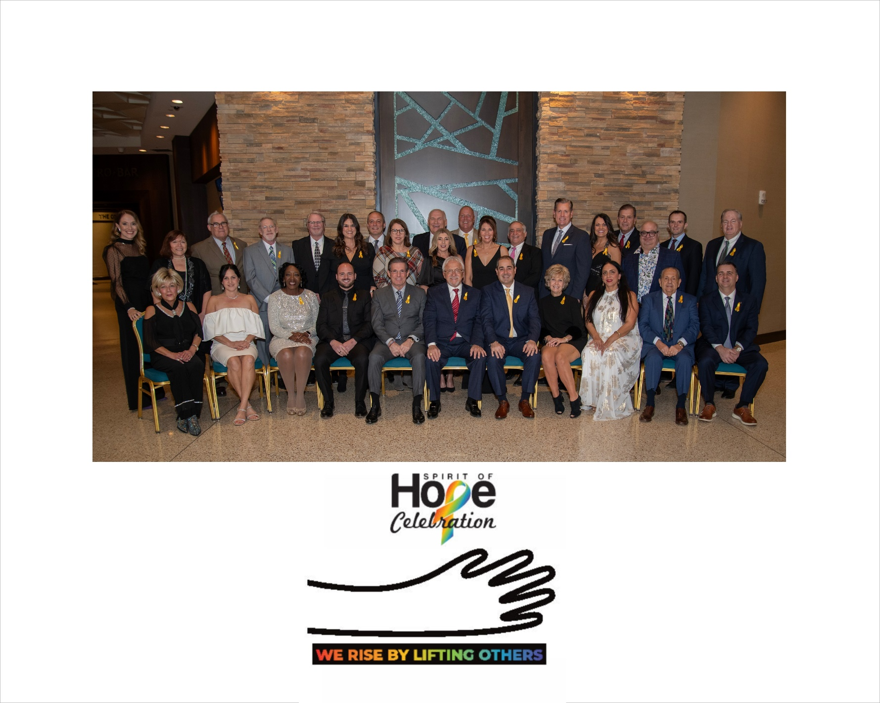

**Front row, seated from left to right:**

Jo Ann Romano Hallesky, Dana Morris, Sonya Eddings, Joe Mattioli, Dino Campitelli, Leo Vergnetti, Board of Ambassadors Chairman, Christopher A. Peters, M.D., Robin Long, Vanessa Vergnetti-Thomas, Pat Sicilio, and Philip Medico.

**Second row, standing from left to right:**Meghan Gagorik, Patty Vergnetti, Richard P. Conaboy Jr., Edward Cosgrove, Joe G. Ferguson, Esq.,Kristie Hynoski, Steven J. Szydlowski, Ph.D., Traci Fosnot, Nevin Gerber, Marta Gomes, Vito Pizzo, Tammy Saunders, Vince Scarpetta, William Davis, Angela Rempe Jones, Nicholas Colangelo, Ph.D., William Rinaldi, Matt Beynon, and James T. Gorman.

**Board of Ambassadors: Absent from photo:** Susan & Jim Brady, Trish Colangelo, John & Jennifer Heil, Charles C. Jefferson, Brian McQuestion, John P. Rodgers, Esq., P. Richard Scheller, Joseph Tomko, Tony Vergnetti, Linda Marino-Brooks, Julie Eisenman, Atty. Chuck Volpe, Tom DePietro, Greg Gagorik, Brigitte Baum, Casey Quinn, Maria Donahue and Mark Mesko.

**Northeast Regional Cancer Institute   
Community-Based Cancer Screening Navigation Program**

One of the vital services that the Cancer Institute offers to our community is the Cancer Screening Navigation Program. This initiative helps low income, uninsured and underinsured individuals not current with recommended colon, breast, and cervical cancer screenings to obtain these screenings.

The Patient Navigator also:

• Helps participants overcome barriers to screening, such as childcare, transportation, and financial needs

• Continues to assist participants through diagnosis, treatment, and aftercare, where necessary

• Connects participants with a medical home (primary care physician or facility) to encourage continuation of preventative care practices

The Cancer Institute relies on the continued support of the community to ensure that the Community Based Cancer Screening Navigation Program can continue to help those most in need access lifesaving cancer screenings and connect to a medical home for ongoing preventative health care. Thank you for your support!

**Proceeds from the Spirit of Hope Celebration   
benefit the Northeast Regional Cancer Institute’s   
Community Based Cancer   
Screening Navigation Program**

The Northeast Regional Cancer Institute serves the following counties: Lackawanna, Luzerne, Wayne, Wyoming, Pike, Susquehanna, and Monroe and has offices in both Scranton and Wilkes-Barre.

**Since the Spirit of Hope Celebration started in 2012, the proceeds from this event have been able to help provide over 12,000 lifesaving screenings.**

**rtheast Regional Cancer Institute**

The Northeast Regional Cancer Institute is a local, non-profit organization working to ease the burden of cancer in Northeastern Pennsylvania. The three main program areas that the Cancer Institute focuses on are: community and patient services, hospital and practice support services, and cancer surveillance. The Cancer Institute is unique in that it is an independent, exclusively local entity. This means that the organization has the flexibility to respond directly to the evolving needs of the community it serves. The Cancer Institute invests 100% of its resources in our region.

**Northeast Regional Cancer Institute Board of Directors**

Robert Cole, PhD– Chair

Fr. Herbert Keller- Vice Chair

Holly Roever Carron - Secretary

John A. Ruddy, M.B.A., D.P.S.- Treasurer

Karen Moran Saunders – President

Susan S. Belin  
Julie Story Byerley, MD, MPH  
Michele Churney, MSN, RN  
William Conaboy, Esq.  
Michael P. Curran   
Maria Montoro Edwards, PhD  
Samuel M. Lesko, M.D., M.P.H  
Cynthia Mailloux, PhD, RN, CNE  
James Pettinato, RN-HP, MHSA  
Christopher Peters, MD  
Susan Shoemaker, Esq.

**PROGRAM ADVERTISEMENT**

|  |  |  |
| --- | --- | --- |
| Full Page Ad (5”w x 8”h) | $250 |  |
| Half Page Ad (5”w x 3.875”h) | $125 |  |
| Quarter Page Ad (2.375”w x 3.875 h) | $75 |  |

|  |  |  |
| --- | --- | --- |
|  | **Presenting Sponsor**  10 Tickets to Event, Full Color Page Ad (5” w x 8”h) and integration into back cover of program  Recognition as Presenting Sponsor in ALL event media communications and advertisements including the video loop, event program; SOH website and Facebook page. event speaking opportunity, signage display and promotional opportunity at event to provide information and giveaways to attendees | **$5,000** |
|  | **Diamond Sponsor**  *8 Tickets to Event, Black & White Page Ad (5” w x 8”h)*  Recognition as Diamond Sponsor in all event communications and signage including the video loop and event program; promotional opportunity at event to provide information and giveaways to attendees and SOH website and Facebook page. | **$2,500** |
|  | **Cocktail/Mocktail Sponsor ( 1 opportunity) *Must be secured by October 7th to order napkins.** 6 Tickets to Event, business logo/name displayed prominently on event signage and promotional materials. Full Black & White Page Ad (5” w x 8”h), Your company name or logo printed on Event Night Cocktail Napkins (if secured by October 7), Logo/Name placement on SOH website and Facebook page. | **$2,500** |
|  | **Platinum Sponsor**  *8 Tickets to Event, Full Black & White Page Ad (5” w x 8”h)*  Recognition as Platinum Sponsor in the video loop and SOH website and Facebook page. | **$2,000** |
|  | **Entertainment Underwriter (1 opportunity)**  6 Tickets to Event, Business logo/name displayed prominently on event signage,Logo/name placement on SOH website and Facebook page, Half Page Black & White Page Ad .5”w x 3.875”h) | **$2,000** |
|  | **Gold Sponsor**  6 Tickets to Event, Half Black & White Page Ad (5” w x 3.875”h)  Recognition as Gold Sponsor in the video loop and SOH website and Facebook page | **$1,500** |
|  | **Emerald Sponsor**  4 Tickets to Event, Half Black & White Page Ad (5” w x 3.875”h)  Recognition as Emerald Sponsor in the video loop and SOH website and Facebook page | **$1,000** |
|  | **Silver Sponsor**  2 Tickets to Event, Quarter Black & White Page Ad (2.375” w x 3.875”h)  Recognition as Silver Sponsor in the video loop and SOH website and Facebook page | **$500** |

|  |
| --- |
| **SPONSORSHIP OPPORTUNITIES (please check your selection)** |

**Please e-mail your high resolution black and white program ad in PDF format no later than Friday, November 1, 2024, to karen.saunders@cancernepa.org.**

Please email your **high resolution black and white** program ad in PDF format no later than **Friday, October 21, 2022 to** [**amanda.marchegiani@cancernepa.org**](mailto:amanda.marchegiani@cancernepa.org)**.**

**Program Advertisements**

The Northeast Regional Cancer Institute is a 501 (c) (3) non-profit, tax-exempt organization. "A copy of the registration and financial information may be obtained from the Pennsylvania Department of State by calling, toll-free, within Pennsylvania, 1 (800) 732-0999. Registration does not imply endorsement.

*Credit card payments can be made by calling the Northeast Regional Cancer Institute at (570) 904-8808.*

Please send this form along with your payment to  
 Northeast Regional Cancer Institute

Attn: Spirit of Hope Celebration, 312 Adams Avenue Scranton, PA 18503

or E-mail to: [Barbara.cerra@cancernepa.org](mailto:Barbara.cerra@cancernepa.org)

**Donor Information  
NAME**:_______________________________________________________ **COMPANY:**___________________________________________________   
**ADDRESS**:____________________________________________________   
**PHONE**:______________________________________________________   
**EMAIL**:_________________________________________________________

**ENCLOSED IS MY CHECK PAYABLE TO “NRCI” IN THE AMOUNT OF $____________.**